Muhammad Ashkar Yousuf Milton

Nelson Marlborough Institute of Technology  DAT-502

database Concept

Table of Contents

DAT502 Assignment 2 3

Semester 2 2017 3

Student Name: Muhammad Ashkar Yousuf Milton 3

1 Physical Design 3

1.1 Design Decisions / Assumptions Made 3

1.2 Data Dictionary and Database size 4

1.3 Database Creation Script 8

2 Database Build 12

3 Data Entry Form 12

4 Test Data 13

4.1 SQL statements to load data 13

4.2 Evidence of Data Loaded 23

5 SQL Queries 27

5.1 Query 1 - 27

5.1.1 Description 27

5.1.2 SQL statement 28

5.1.3 Results 28

5.2 Query 2 - 28

5.2.1 Description 28

5.2.2 SQL statement 28

5.2.3 Results 28

5.3 Query 3 - 29

5.3.1 Description 29

5.3.2 SQL statement 29

5.3.3 Results 29

5.4 Query 4 - 30

5.4.1 Description 30

5.4.2 SQL statement 30

5.4.3 Results 30

5.5 Query 5 - 30

5.5.1 Description 30

5.5.2 SQL statement 30

5.5.3 Results 31

6 Report 32

7 Problems Encountered 33

# DAT502 Assignment 2

# Semester 2 2017

# Student Name: Muhammad Ashkar Yousuf Milton

# Physical Design

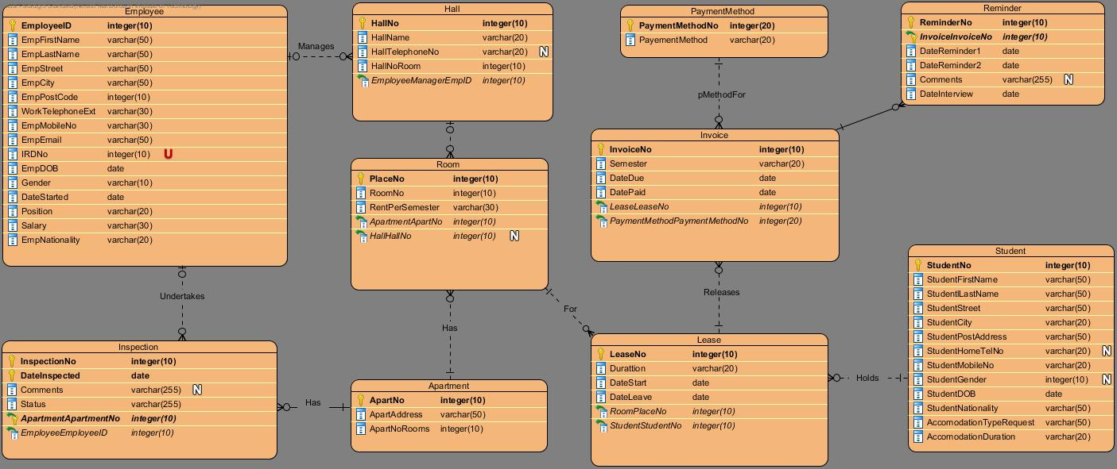

## Design Decisions / Assumptions Made

* Inspection

**“InspectionNo”** is added as the Primary Key, because the Inspection table has repeating information. It is there so that it has unique number to identify. This unique identifier will prevent any clash with the repeating inspection dates set by any employee.

* EmployeeID is being used instead of EmployeeNo
* EmpMobileNo is also added because people nowadays have access to mobile phones instead of home phone.
* Reminder

**“ReminderNo”** is used as a primary key in Reminder because it is easier to find the number and to ensure data in the specific column is unique.

* I added EmpNationality in the Employee table because lot of Employee came from oversees.
* Hall

**“HallNo”** is used as a Primary Key in the Hall table instead of HallName, because the Hall table has repeating information. It is there so that it has unique number to identify. This unique identifier will prevent any clash with the repeating hall number that has been set up.

* Reminder

**“ReminderNo”** is used as a Primary Key in Reminder Table instead of InvoiceNo, because the Reminder table has repeating information. It is there so that it has unique number to identify. This unique identifier will prevent any clash with the repeating reminder number that has been set up.

## Data Dictionary and Database size

* + - Employee

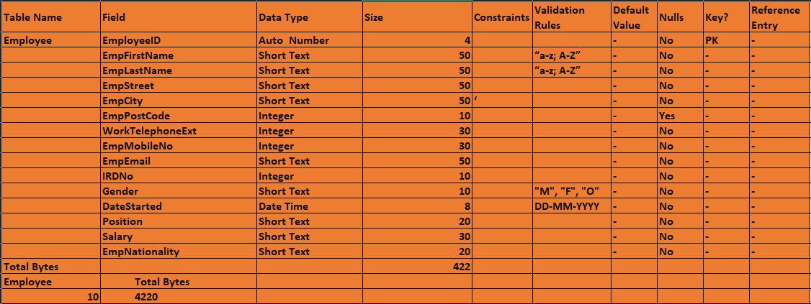

* + - Hall

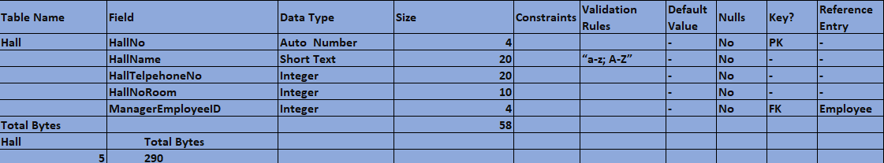

* + - Room

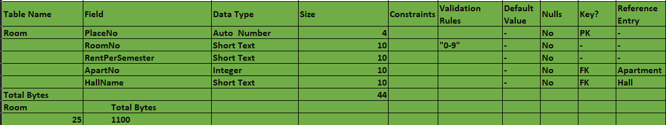

* + - Apartment

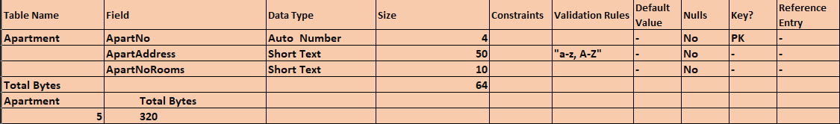

* + - Inspection

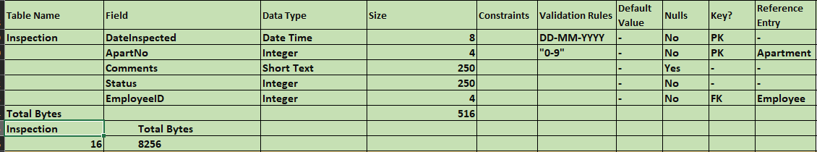

* + - Invoice

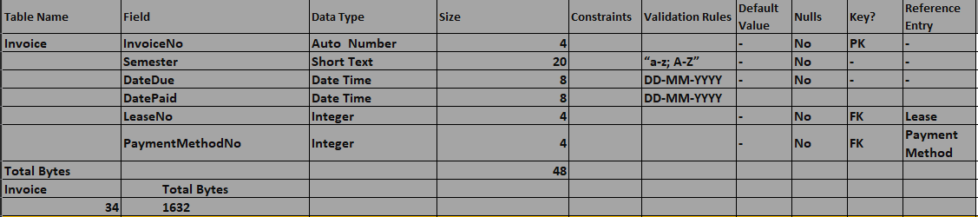

* + - Lease

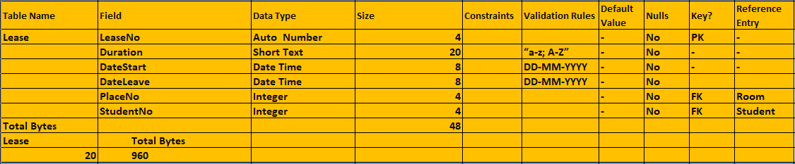

* + - Reminder

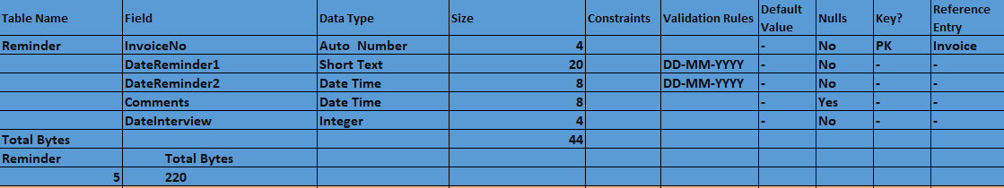

* + - Student

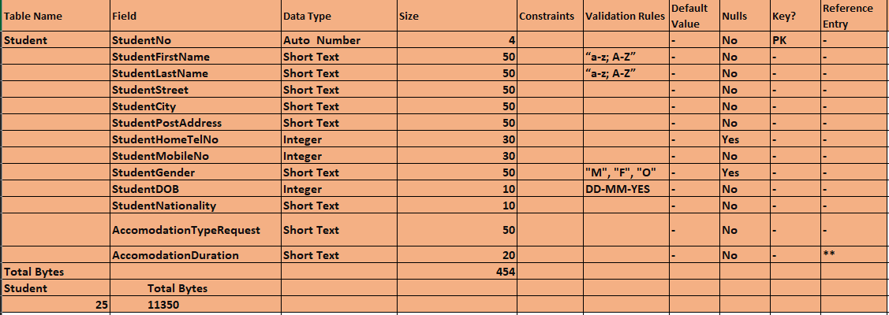

* + - Payment Method

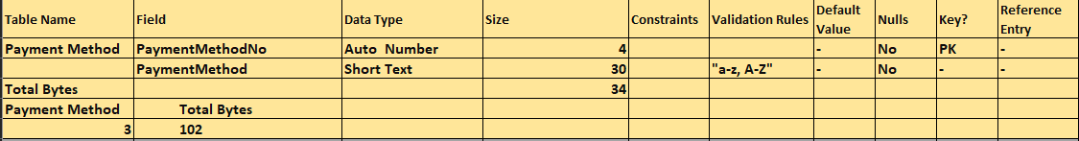

* + - Database Size

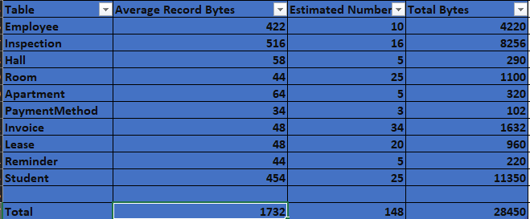

## Database Creation Script

* + - Query of Students

CREATE TABLE Student

(StudentNo AUTOINCREMENT PRIMARY KEY,

StudentFirstName varchar(50) NOT NULL,

StudentLastName varchar(50) NOT NULL,

StudentStreet varchar (20) NOT NULL,

StudentCity varchar (20) NOT NULL,

StudentPostAddress varchar(50) NOT NULL,

StudentHomeTelNo int NOT NULL,

StudentGender varchar(10) NOT NULL,

StudentDOB datetime NOT NULL,

StudentNationlaity varchar(30) NOT NULL,

AccomodationTypeRequest varchar(30) NOT NULL,

AccomodationDuration varchar(30));

* + - Query of Inspection

CREATE TABLE Inspection

(InspectionNo AUTOINCREMENT PRIMARY KEY,

ApartNo int NOT NULL,

DateInspected datetime NOT NULL,

Comments varchar(255),

Status varchar(255),

EmployeeID int NOT NULL,

FOREIGN KEY (EmployeeID) REFERENCES Employee(EmployeeID),

FOREIGN KEY (ApartNo) REFERENCES Apartment(ApartNo));

* + - Query of Hall

CREATE TABLE Hall

(HallNo AUTOINCREMENT PRIMARY KEY,

HallName varchar(30) NOT NULL,

HallTelephoneNo varchar(20) NOT NULL,

HallNoRoom int NOT NULL,

ManagerEmpID int NOT NULL,

FOREIGN KEY (ManagerEmpID) REFERENCES Employee(EmployeeID));

* + - Query of Room

CREATE TABLE Room

(PlaceNo AUTOINCREMENT PRIMARY KEY,

RoomNo int NOT NULL,

RentPerSemester varchar(30) NOT NULL,

ApartNo int NOT NULL,

HallNo int NOT NULL,

FOREIGN KEY (ApartNo) REFERENCES Apartment(ApartNo),

FOREIGN KEY (HallNo) REFERENCES Hall(HallNo));

* + - Query of Apartment

CREATE TABLE Apartment

(ApartNo AUTOINCREMENT PRIMARY KEY,

ApartmentAddress varchar(50),

ApartNoRooms int);

* + - Query of Payment Method

CREATE TABLE PaymentMethod

(PaymentMethodNo AUTOINCREMENT PRIMARY KEY,

PaymentMethod varchar(20));

* + - Query of Invoice

CREATE TABLE Invoice

(InvoiceNo AUTOINCREMENT PRIMARY KEY,

Semester varchar(20) NOT NULL,

DateDue datetime NOT NULL,

DatePaid datetime NOT NULL,

LeaseNo int NOT NULL,

PaymentMethodNo int NOT NULL,

FOREIGN KEY (LeaseNo) REFERENCES Lease(LeaseNo),

FOREIGN KEY (PaymentMethodNo) REFERENCES PaymentMethod(PaymentMethodNo));

* + - Query of Lease

CREATE TABLE Lease

(LeaseNo AUTOINCREMENT PRIMARY KEY,

Duratioin varchar(20) NOT NULL,

DateStart datetime NOT NULL,

DateLeave datetime NOT NULL,

PlaceNo int NOT NULL,

StudentNo int NOT NULL,

FOREIGN KEY (StudentNo) REFERENCES Student(StudentNo),

FOREIGN KEY (PlaceNo) REFERENCES Room(PlaceNo));

* + - Query of Reminder

CREATE TABLE Reminder

(ReminderNo AUTOINCREMENT PRIMARY KEY,

InvoiceNo integer,

DateReminder1 datetime NOT NULL,

DateReminder2 datetime NOT NULL,

Comments varchar(255),

DateInterview datetime NOT NULL,

FOREIGN KEY (InvoiceNo) REFERENCES Invoice(InvoiceNo));

* + - Query of Employee

CREATE TABLE Employee

(EmployeeID AUTOINCREMENT PRIMARY KEY,

EmpFirstName varchar(50) NOT NULL,

EmpLastName varchar(50) NOT NULL,

EmpStreet varchar(50) NOT NULL,

EmpCity varchar(25) NOT NULL,

EmpPostCode int NOT NULL,

WorkTelephoneExt varchar(20) NOT NULL,

EmpMobileNo varchar(30) NOT NULL,

EmpEmail varchar(30) NOT NULL,

IRDNo int NOT NULL,

EmpDOB datetime NOT NULL,

Gender varchar(10) NOT NULL,

DateStarted datetime NOT NULL,

Position varchar(20) NOT NULL,

Salary varchar(20) NOT NULL,

EmpNationlaity varchar(20) NOT NULL);

# Database Build

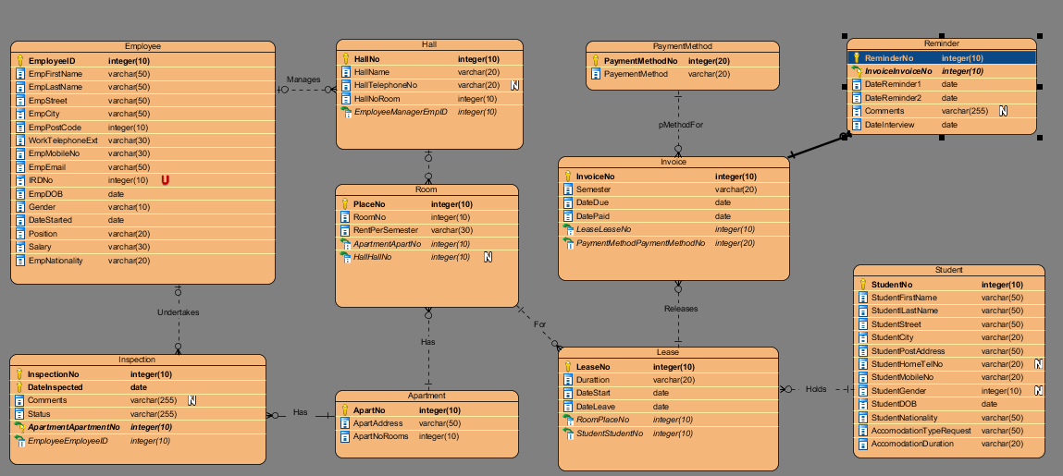

# Data Entry Form

**Data Entry Form for Employee**

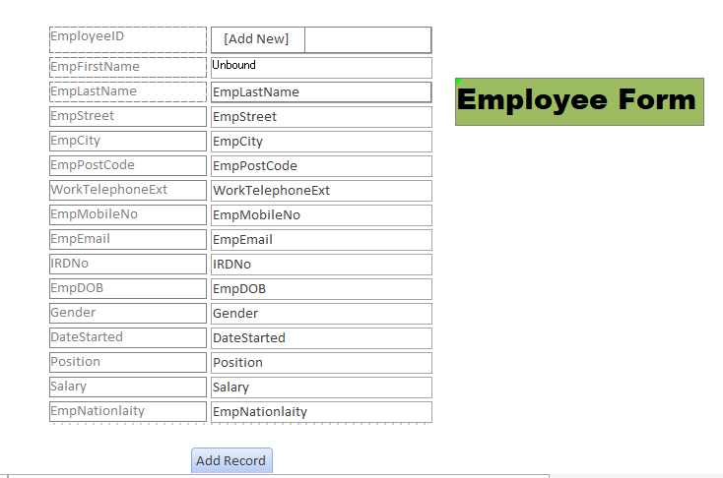

**Data Entry Form for Students**

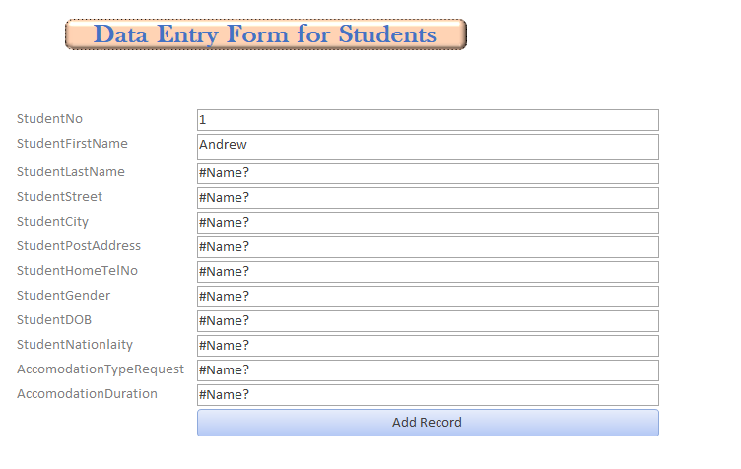

# Test Data

## SQL statements to load data

1. ***Apartment***

* INSERT INTO Apartment ( ApartmentAddress, ApartNoRooms )VALUES (‘Sarjau Apartment, 235 Vincent Street, Nelson’, ‘ 1’);
* INSERT INTO Apartment ( ApartmentAddress, ApartNoRooms )VALUES (‘Nikau Apartment, 89 Nile Street, Nelson ‘, ‘ 2’);
* INSERT INTO Apartment ( ApartmentAddress, ApartNoRooms )VALUES (‘Lafayete Apartment, 23 Nile Street, Nelson ‘, ‘ 3’);
* INSERT INTO Apartment ( ApartmentAddress, ApartNoRooms )VALUES (‘Sarjau Apartment,15 Central Nelson, Nelson’, ’4’);
* INSERT INTO Apartment ( ApartmentAddress, ApartNoRooms )VALUES (‘Vincent Apartment, 3 Ridgge Valley, Nelson ‘, ‘ 5’);

1. ***Hall***

* INSERT INTO Hall ( HallName, HallTelephoneNo, HallNoRoom, ManagerEmpID ) VALUES ('Nikau Hall', '0223564601', '3', '1');
* INSERT INTO Hall ( HallName, HallTelephoneNo, HallNoRoom, ManagerEmpID ) VALUES ('Sarjau Hall', ' 0223546020', '2', '2');
* INSERT INTO Hall ( HallName, HallTelephoneNo, HallNoRoom, ManagerEmpID ) VALUES (' Lafayete Hall', '0154678880', '3', '1');
* INSERT INTO Hall ( HallName, HallTelephoneNo, HallNoRoom, ManagerEmpID ) VALUES ('Hijaku Hall', '0154478896', '2', '3');
* INSERT INTO Hall ( HallName, HallTelephoneNo, HallNoRoom, ManagerEmpID ) VALUES ('Nikkon Hall', ' 0225469990', '3', '2');

1. ***Inspection***

* INSERT INTO Inspection (ApartNo, DateInspected, Comments, Status, EmployeeID ) VALUES ('1', '1/1/2017', 'None', 'Excellent', '1');
* INSERT INTO Inspection (ApartNo, DateInspected, Comments, Status, EmployeeID ) VALUES ('3', '1/1/2017', 'Punched a hole', 'Good', '3');
* INSERT INTO Inspection (ApartNo, DateInspected, Comments, Status, EmployeeID ) VALUES ('2', '1/1/2017, ' Need Cleaning', 'Very Good', '4');
* INSERT INTO Inspection (ApartNo, DateInspected, Comments, Status, EmployeeID ) VALUES ('5', '1/1/2017, ' Need Fixing', 'Excellent', '6');
* INSERT INTO Inspection (ApartNo, DateInspected, Comments, Status, EmployeeID ) VALUES ('4', '1/1/2017, ' Needs Curtain', 'Good', '5');
* INSERT INTO Inspection (ApartNo, DateInspected, Comments, Status, EmployeeID ) VALUES ('1', '6/1/2017, ' Needs Vaccuming', 'Poor', '7');
* INSERT INTO Inspection (ApartNo, DateInspected, Comments, Status, EmployeeID ) VALUES ('4', '6/1/2017, ' Broke the toilet', 'Very Poor', '8');
* INSERT INTO Inspection (ApartNo, DateInspected, Comments, Status, EmployeeID ) VALUES ('5', '6/1/2017, ' Needs Fixing and Cleaning', 'Good', '9');
* INSERT INTO Inspection (ApartNo, DateInspected, Comments, Status, EmployeeID ) VALUES ('2', '6/1/2017, ' Needs Paint', 'Very Good', '2');
* INSERT INTO Inspection (ApartNo, DateInspected, Comments, Status, EmployeeID ) VALUES ('3', '6/1/2017, ' Perfect', 'Good', '10');
* INSERT INTO Inspection (ApartNo, DateInspected, Comments, Status, EmployeeID ) VALUES ('2', '6/1/2017, ' Perfect', 'Good', '2');
* INSERT INTO Inspection (ApartNo, DateInspected, Comments, Status, EmployeeID ) VALUES ('4', '12/1/2017, ' Needs Plumber', 'Excellent', '4');
* INSERT INTO Inspection (ApartNo, DateInspected, Comments, Status, EmployeeID ) VALUES ('3', '12/1/2017, ' Needs Fixing the tap', 'Good', '5');
* INSERT INTO Inspection (ApartNo, DateInspected, Comments, Status, EmployeeID ) VALUES ('5', '12/1/2017, ' Needs Fixing', 'Excellent', '6');
* INSERT INTO Inspection (ApartNo, DateInspected, Comments, Status, EmployeeID ) VALUES ('1', '12/1/2017, ' Nothing Needed', 'Excellent', '7');
* INSERT INTO Inspection (ApartNo, DateInspected, Comments, Status, EmployeeID ) VALUES ('2', '12/1/2017, ' Needs Plaster', 'Good', '8');

1. ***Room***

* INSERT INTO Room (RoomNo, RentPerSemester, HallNo ) VALUES ('8', '$2000', '1');
* INSERT INTO Room (RoomNo, RentPerSemester, HallNo ) VALUES ('3', '$1500', '2');
* INSERT INTO Room (RoomNo, RentPerSemester, ApartNo ) VALUES ('4', '$1800', '3');
* INSERT INTO Room (RoomNo, RentPerSemester, ApartNo ) VALUES ('5', '$1750', '4');
* INSERT INTO Room (RoomNo, RentPerSemester, ApartNo ) VALUES ('7', '$1600', '5');
* INSERT INTO Room (RoomNo, RentPerSemester, ApartNo ) VALUES ('6', '$2000', '1');
* INSERT INTO Room (RoomNo, RentPerSemester, ApartNo ) VALUES ('5', '$1500', '2');
* INSERT INTO Room (RoomNo, RentPerSemester, ApartNo ) VALUES ('9', '$1800', '3');
* INSERT INTO Room (RoomNo, RentPerSemester, ApartNo ) VALUES ('1', '$1750', '4');
* INSERT INTO Room (RoomNo, RentPerSemester, ApartNo ) VALUES ('2', '$1600', '5');
* INSERT INTO Room (RoomNo, RentPerSemester, ApartNo ) VALUES ('3', '$1500', '2');
* INSERT INTO Room (RoomNo, RentPerSemester, ApartNo ) VALUES ('2', '$1750', '4');
* INSERT INTO Room (RoomNo, RentPerSemester, HallNo )VALUES ('3', '$1800', '1');
* INSERT INTO Room (RoomNo, RentPerSemester, HallNo )VALUES ('3', '$1600', '2');
* INSERT INTO Room (RoomNo, RentPerSemester, HallNo )VALUES ('4', '$1700', '3');
* INSERT INTO Room (RoomNo, RentPerSemester, HallNo )VALUES ('5', '$1900', '4');
* INSERT INTO Room (RoomNo, RentPerSemester, HallNo )VALUES ('3', '$2000', '5');
* INSERT INTO Room (RoomNo, RentPerSemester, HallNo )VALUES ('4', '$1800', '1');
* INSERT INTO Room (RoomNo, RentPerSemester, HallNo )VALUES ('4', '$1600', '2');
* INSERT INTO Room (RoomNo, RentPerSemester, HallNo )VALUES ('1', '$1700', '3');
* INSERT INTO Room (RoomNo, RentPerSemester, HallNo )VALUES ('2', '$1900', '4');
* INSERT INTO Room (RoomNo, RentPerSemester, HallNo )VALUES ('3', '$2000', '5');
* INSERT INTO Room (RoomNo, RentPerSemester, HallNo )VALUES ('3', '$1800', '1');
* INSERT INTO Room (RoomNo, RentPerSemester, HallNo )VALUES ('4', '$1700', '3');
* INSERT INTO Room (RoomNo, RentPerSemester, HallNo )VALUES ('2', '$2000', '5');

1. ***Lease***

* INSERT INTO Lease (Duration, DateStart, DateLeave, StudentNo, PlaceNo ) VALUES ('1 Year', '10/3/2016', '10/3/2017', '1', '9');
* INSERT INTO Lease (Duration, DateStart, DateLeave, StudentNo, PlaceNo ) VALUES ('1 Year', '9/1/2017', '11/3/2017', '2', '3');
* INSERT INTO Lease (Duration, DateStart, DateLeave, StudentNo, PlaceNo ) VALUES ('6 Months', '10/9/2013', '12/21/2018', '3', '10');
* INSERT INTO Lease (Duration, DateStart, DateLeave, StudentNo, PlaceNo ) VALUES ('6 Months', '11/2/2016', '11/3/2017', '11', '11');
* INSERT INTO Lease (Duration, DateStart, DateLeave, StudentNo, PlaceNo ) VALUES ('1 Year', '9/2/2017', '11/4/2017', '5', '12');
* INSERT INTO Lease (Duration, DateStart, DateLeave, StudentNo, PlaceNo ) VALUES ('1 Year', '11/2/2017', '11/16/2017', '6', '2');
* INSERT INTO Lease (Duration, DateStart, DateLeave, StudentNo, PlaceNo ) VALUES ('1 Year', '11/4/2016', '11/23/2017', '7', '15');
* INSERT INTO Lease (Duration, DateStart, DateLeave, StudentNo, PlaceNo ) VALUES ('6 Months', '12/1/2016', '12/21/2017', '8', '8');
* INSERT INTO Lease (Duration, DateStart, DateLeave, StudentNo, PlaceNo ) VALUES ('6 Months', '7/18/2016', '8/8/2020', '10', '9');
* INSERT INTO Lease (Duration, DateStart, DateLeave, StudentNo, PlaceNo ) VALUES ('6 Months', '1/2/2018', '7/4/2018', '9', '5');
* INSERT INTO Lease (Duration, DateStart, DateLeave, StudentNo, PlaceNo ) VALUES ('1 Year', '1/5/2017', '12/11/2017', '12', '13');
* INSERT INTO Lease (Duration, DateStart, DateLeave, StudentNo, PlaceNo ) VALUES ('1 Year', '10/3/2016', '10/3/2017', '4', '8');
* INSERT INTO Lease (Duration, DateStart, DateLeave, StudentNo, PlaceNo ) VALUES ('6 Months', '6/13/2017', '12/13/2017', '13', '1');
* INSERT INTO Lease (Duration, DateStart, DateLeave, StudentNo, PlaceNo ) VALUES ('1 Year', '6/7/2016', '6/7/2017', '15', '4');
* INSERT INTO Lease (Duration, DateStart, DateLeave, StudentNo, PlaceNo ) VALUES ('6 Months', '5/9/2017', '11/7/2017', '17', '7');
* INSERT INTO Lease (Duration, DateStart, DateLeave, StudentNo, PlaceNo ) VALUES ('1 Year', '1/1/2016', '1/2/2017', '19', '17');
* INSERT INTO Lease (Duration, DateStart, DateLeave, StudentNo, PlaceNo ) VALUES ('1 Year', '11/11/2016', '11/11/2017', '21', '18');
* INSERT INTO Lease (Duration, DateStart, DateLeave, StudentNo, PlaceNo ) VALUES ('6 Months', '2/2/2017', '8/8/2017', '18', '16');
* INSERT INTO Lease (Duration, DateStart, DateLeave, StudentNo, PlaceNo ) VALUES ('1 Year', '2/4/2016', '2/5/2017', '22', '19');
* INSERT INTO Lease (Duration, DateStart, DateLeave, StudentNo, PlaceNo ) VALUES ('1 Year', '12/4/2016', '12/4/2017', '24', '20');

1. ***Lease***

* INSERT INTO Reminder (InvoiceNo, DateReminder1, DateReminder2, Comments, DateInterview ) VALUES ('1', '2/15/2016', '3/1/2016', 'Need to Pay the Rent on time', '3/3/2016');
* INSERT INTO Reminder (InvoiceNo, DateReminder1, DateReminder2, Comments, DateInterview ) VALUES ('3', '10/20/2017', '11/24/2017', ' Needs talking', '11/28/2016');
* INSERT INTO Reminder (InvoiceNo, DateReminder1, DateReminder2, Comments, DateInterview ) VALUES ('5', '9/5/2017', '9/13/2016', 'Need to Pay the Rent on time', '9/15/2017');
* INSERT INTO Reminder (InvoiceNo, DateReminder1, DateReminder2, Comments, DateInterview ) VALUES ('7', '5/3/2017', '5/6/2017', Need to control noise', '5/8/2017');
* INSERT INTO Reminder (InvoiceNo, DateReminder1, DateReminder2, Comments, DateInterview ) VALUES ('9', '11/10/2017', '11/20/2017', ' Needs Talking', '11/27/2017');

1. ***Payment Method***

* INSERT INTO PaymentMethod (PaymentMethod ) VALUES ('Cash');
* INSERT INTO PaymentMethod (PaymentMethod ) VALUES ('Cash');
* INSERT INTO PaymentMethod (PaymentMethod ) VALUES ('Cash');

1. ***Invoice***

* INSERT INTO Invoice (Semester, DateDue, DatePaid, LeaseNo, PaymentMethodNo) VALUES ('1st Semester', '1/2/2017', '1/4/2017', '1', '1');
* INSERT INTO Invoice (Semester, DateDue, DatePaid, LeaseNo, PaymentMethodNo) VALUES ('2nd Semester', '6/15/2017', '6/17/2017', '1', '2');
* INSERT INTO Invoice (Semester, DateDue, DatePaid, LeaseNo, PaymentMethodNo) VALUES ('1st Semester', '1/1/2017', '1/3/2017', '2', '3');
* INSERT INTO Invoice (Semester, DateDue, DatePaid, LeaseNo, PaymentMethodNo) VALUES ('2nd Semester', '6/4/2017', '6/7/2017', '2', '1');
* INSERT INTO Invoice (Semester, DateDue, DatePaid, LeaseNo, PaymentMethodNo) VALUES ('1st Semester', '11/15/2017', '11/22/2017', '3', '2');
* INSERT INTO Invoice (Semester, DateDue, DatePaid, LeaseNo, PaymentMethodNo) VALUES ('1st Semester', '10/9/2017', '10/11/2017', '4', '3');
* INSERT INTO Invoice (Semester, DateDue, DatePaid, LeaseNo, PaymentMethodNo) VALUES ('1st Semester', '5/7/2017', '5/10/2017', '5', '1');
* INSERT INTO Invoice (Semester, DateDue, DatePaid, LeaseNo, PaymentMethodNo) VALUES ('2nd Semester', '11/22/2017', '11/29/2017', '5', '2');
* INSERT INTO Invoice (Semester, DateDue, DatePaid, LeaseNo, PaymentMethodNo) VALUES ('1st Semester', '5/17/2017', '5/23/2017', '6', '3');
* INSERT INTO Invoice (Semester, DateDue, DatePaid, LeaseNo, PaymentMethodNo) VALUES ('2nd Semester', '11/15/2016', '11/16/2016', '6', '1');
* INSERT INTO Invoice (Semester, DateDue, DatePaid, LeaseNo, PaymentMethodNo) VALUES ('1st Semester', '1/1/2017', '1/3/2017', '7', '2');
* INSERT INTO Invoice (Semester, DateDue, DatePaid, LeaseNo, PaymentMethodNo) VALUES ('2nd Semester', '7/3/2017', '7/6/2017', '7', '3');
* INSERT INTO Invoice (Semester, DateDue, DatePaid, LeaseNo, PaymentMethodNo) VALUES ('1st Semester', '2/2/2017', '2/5/2017', '8', '1');
* INSERT INTO Invoice (Semester, DateDue, DatePaid, LeaseNo, PaymentMethodNo) VALUES ('2nd Semester', '8/3/2017', '5/15/2017', '8', '2');
* INSERT INTO Invoice (Semester, DateDue, DatePaid, LeaseNo, PaymentMethodNo) VALUES ('1st Semester', '5/12/2017', '5/15/2017', '9', '3');
* INSERT INTO Invoice (Semester, DateDue, DatePaid, LeaseNo, PaymentMethodNo) VALUES ('2nd Semester', '11/15/2017', '11/19/2017', '9', '1');
* INSERT INTO Invoice (Semester, DateDue, DatePaid, LeaseNo, PaymentMethodNo) VALUES ('1st Semester', '11/16/2017', '11/18/2017', '10', '2');
* INSERT INTO Invoice (Semester, DateDue, DatePaid, LeaseNo, PaymentMethodNo) VALUES ('1st Semester', '11/17/2017', '11/19/2017', '11', '3');
* INSERT INTO Invoice (Semester, DateDue, DatePaid, LeaseNo, PaymentMethodNo) VALUES ('2nd Semester', '5/21/2017', '5/25/2017', '11', '1');
* INSERT INTO Invoice (Semester, DateDue, DatePaid, LeaseNo, PaymentMethodNo) VALUES ('1st Semester', '4/12/2017', '4/19/2017', '12', '2');
* INSERT INTO Invoice (Semester, DateDue, DatePaid, LeaseNo, PaymentMethodNo) VALUES ('2nd Semester', '10/2/2017', '10/6/2017', '12', '3');
* INSERT INTO Invoice (Semester, DateDue, DatePaid, LeaseNo, PaymentMethodNo) VALUES ('1st Semester', '11/2/2017', '11/5/2017', '13', '1');
* INSERT INTO Invoice (Semester, DateDue, DatePaid, LeaseNo, PaymentMethodNo) VALUES ('1st Semester', '9/8/2017', '9/9/2017', '14', '2');
* INSERT INTO Invoice (Semester, DateDue, DatePaid, LeaseNo, PaymentMethodNo) VALUES ('2nd Semester', '3/21/2017', '3/22/2017', '14', '3');
* INSERT INTO Invoice (Semester, DateDue, DatePaid, LeaseNo, PaymentMethodNo) VALUES ('1st Semester', '3/3/2017', '3/5/2017', '15', '1');
* INSERT INTO Invoice (Semester, DateDue, DatePaid, LeaseNo, PaymentMethodNo) VALUES ('1st Semester', '5/12/2017', '5/13/2017', '16', '2');
* INSERT INTO Invoice (Semester, DateDue, DatePaid, LeaseNo, PaymentMethodNo) VALUES ('2nd Semester', '11/12/2017', '11/13/2017', '16', '3');
* INSERT INTO Invoice (Semester, DateDue, DatePaid, LeaseNo, PaymentMethodNo) VALUES ('1st Semester', '4/27/2017', '4/28/2017', '17', '1');
* INSERT INTO Invoice (Semester, DateDue, DatePaid, LeaseNo, PaymentMethodNo) VALUES ('2nd Semester', '10/29/2017', '10/30/2017', '17', '2');
* INSERT INTO Invoice (Semester, DateDue, DatePaid, LeaseNo, PaymentMethodNo) VALUES ('1st Semester', '1/1/2017', '1/3/2017', '18', '3');
* INSERT INTO Invoice (Semester, DateDue, DatePaid, LeaseNo, PaymentMethodNo) VALUES ('1st Semester', '4/5/2017', '4/8/2017', '19', '1');
* INSERT INTO Invoice (Semester, DateDue, DatePaid, LeaseNo, PaymentMethodNo) VALUES ('2nd Semester', '10/16/2017', '10/18/2017', '19', '2');
* INSERT INTO Invoice (Semester, DateDue, DatePaid, LeaseNo, PaymentMethodNo) VALUES ('1st Semester', '2/2/2017', '2/5/2017', '20', '3');
* INSERT INTO Invoice (Semester, DateDue, DatePaid, LeaseNo, PaymentMethodNo) VALUES ('2nd Semester', '8/3/2017', '8/5/2017', '20', '1');

## Evidence of Data Loaded

1. ***Apartment***

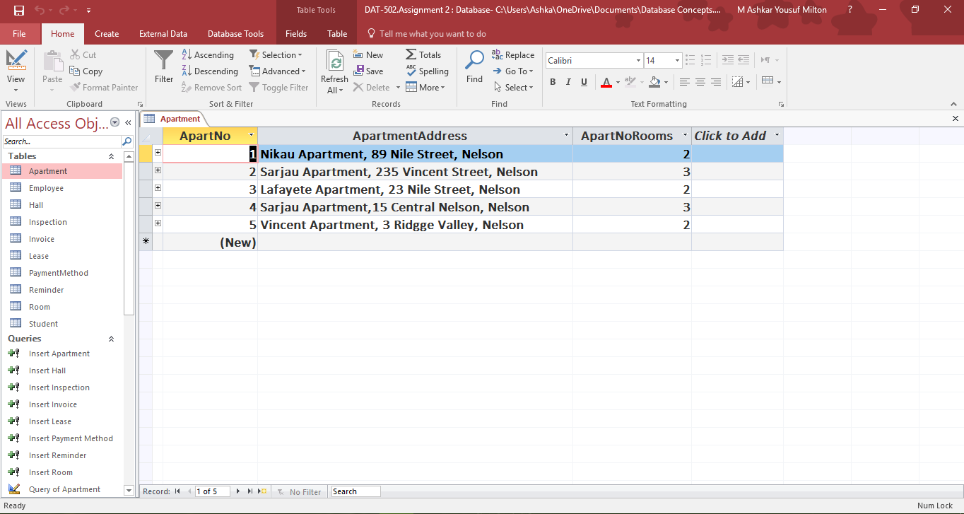

1. ***Hall***

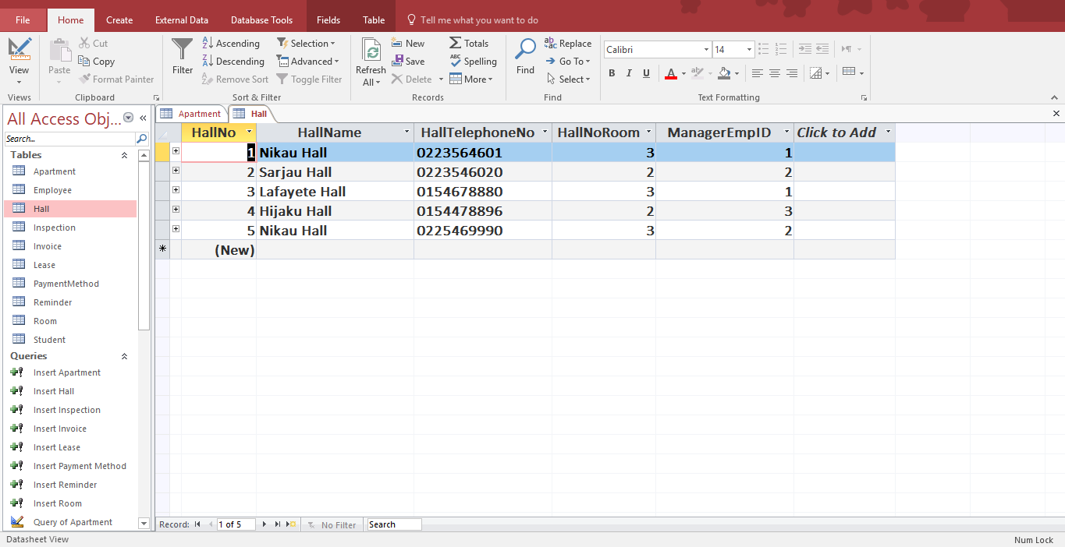

1. ***Inspection***

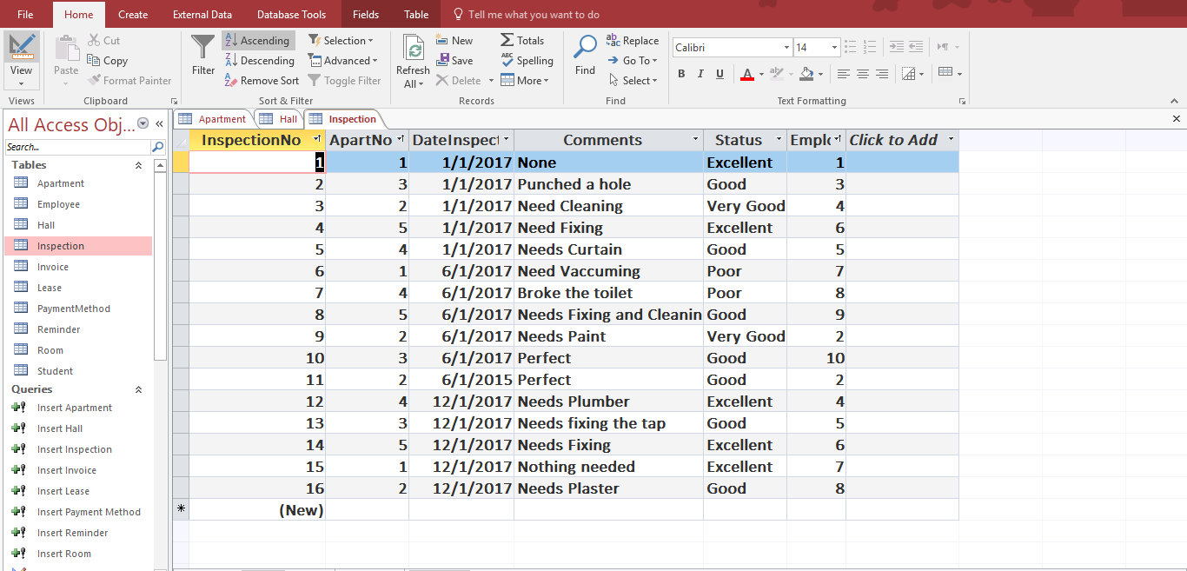

1. ***Room***

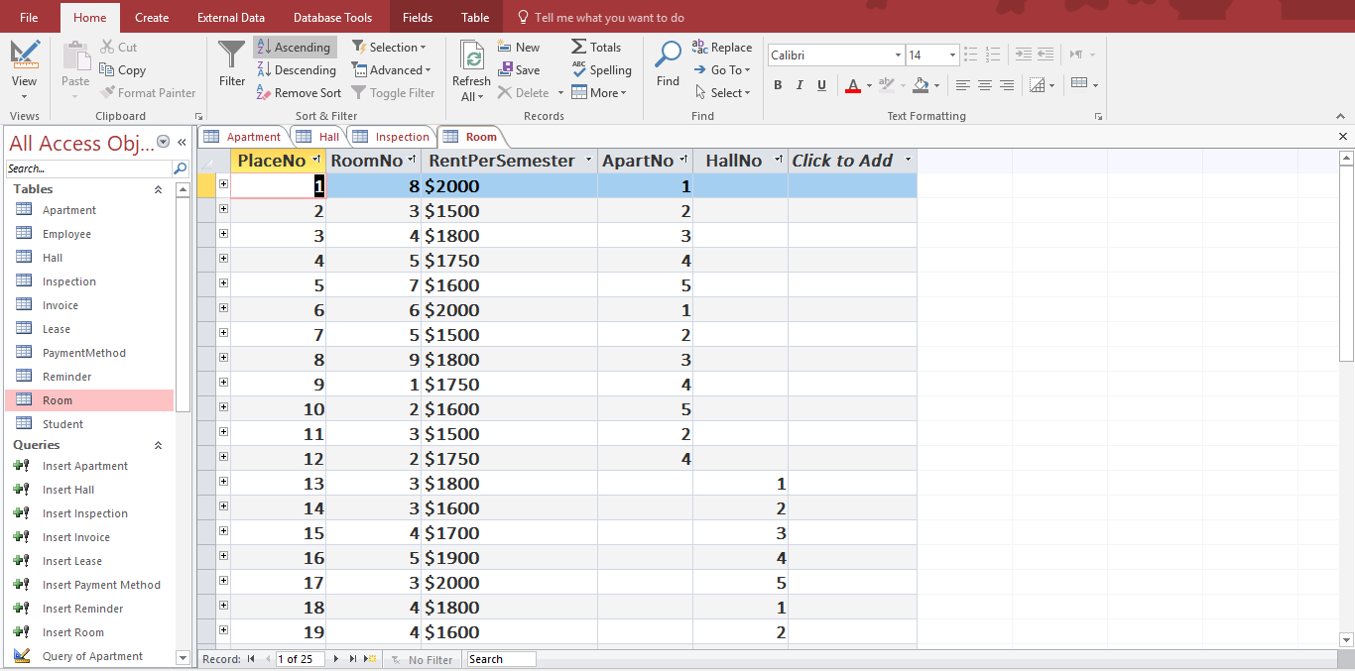

1. ***Lease***

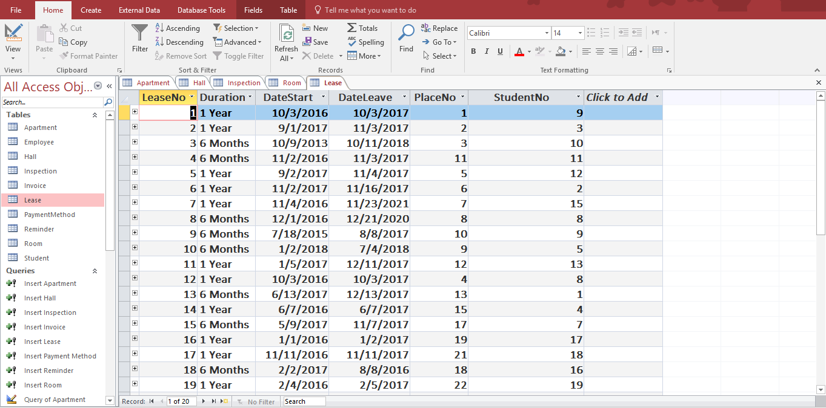

1. ***Reminder***

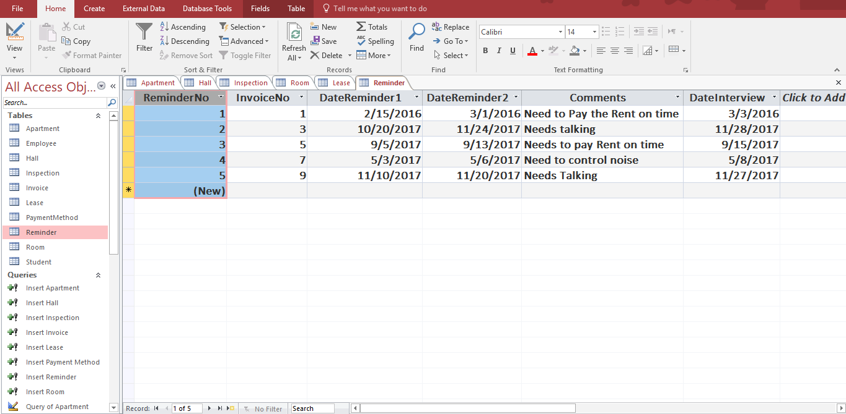

1. ***Payment Method***

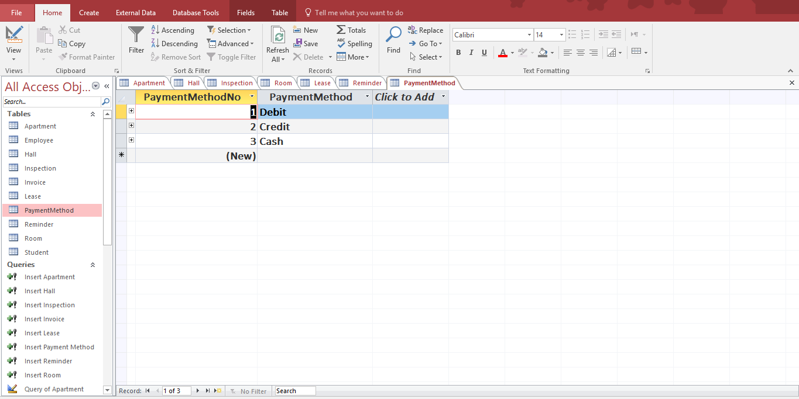

1. ***Invoice***

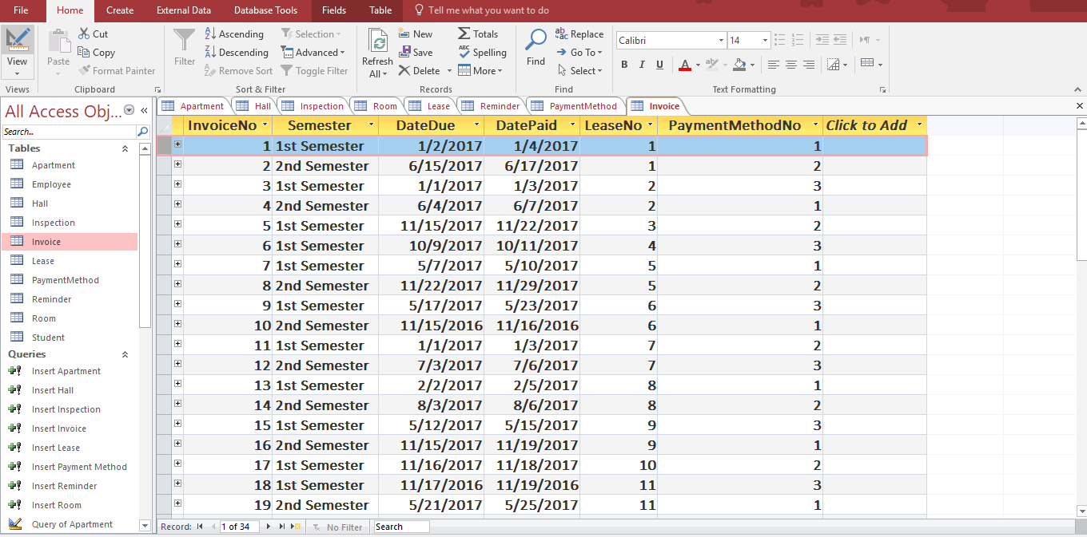

1. ***Student***

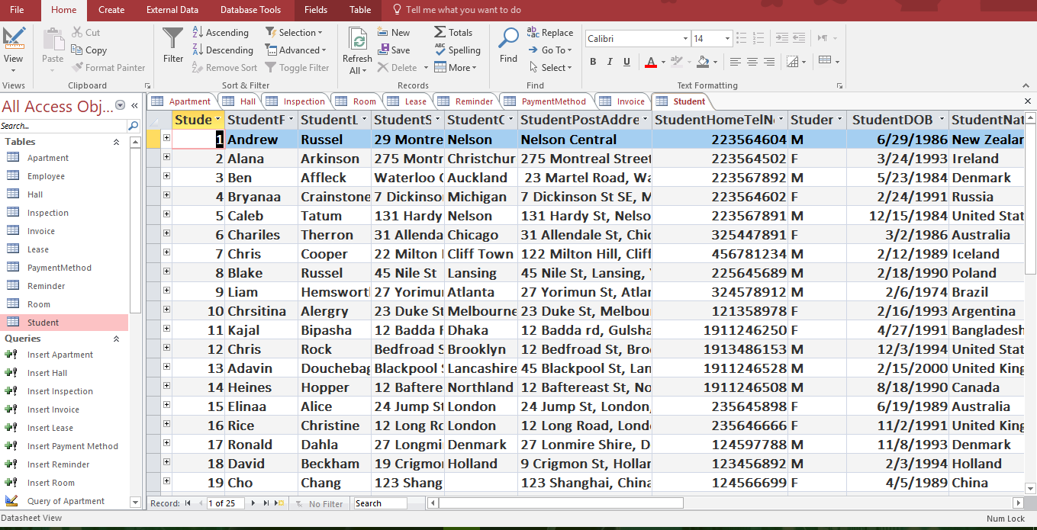

1. ***Employee***

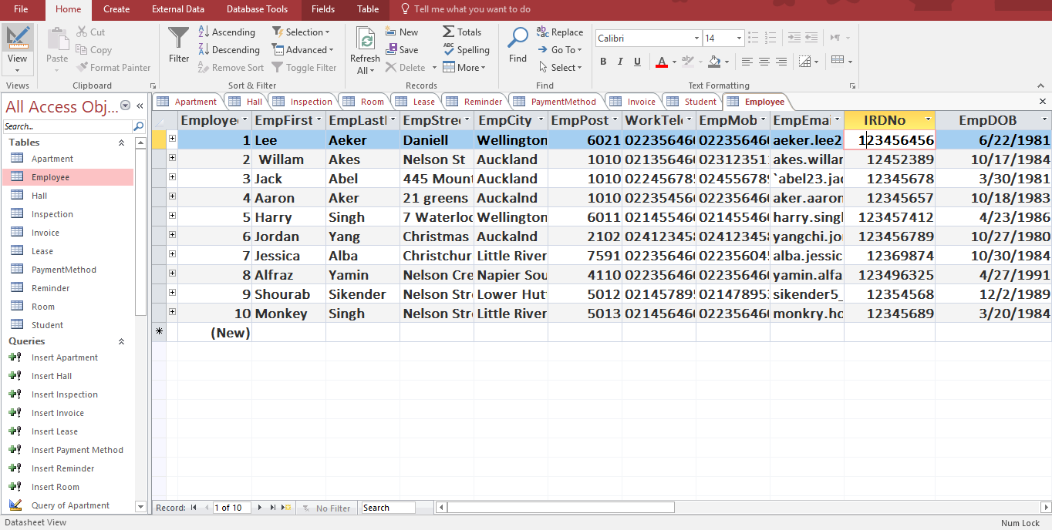

# SQL Queries

## Query 1 -

### Description

* This statement will show a list of all the students in a particular Hall of Residence. For the particular Hall, I had chosen Nikau Hall.

### SQL statement

* SELECT Student.StudentFirstName, Student.StudentLastName, Hall.HallNameFROM (Hall INNER JOIN Room ON Hall.HallNo = Room.HallNo) INNER JOIN (Student INNER JOIN Lease ON Student.StudentNo = Lease.StudentNo) ON Room.PlaceNo = Lease.PlaceNo WHERE (Hall.HallName="Nikau Hall");

### Results

* Screenshot

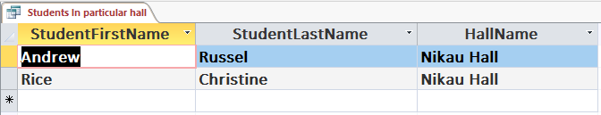

## Query 2 -

### Description

* This statement will show a list of all the students who have been sent one reminder notice.

### SQL statement

* SELECT Student.StudentFirstName, Student.StudentLastName, Reminder.DateReminder1 FROM ((Student INNER JOIN Lease ON Student.StudentNo = Lease.StudentNo) INNER JOIN Invoice ON Lease.LeaseNo = Invoice.LeaseNo) INNER JOIN Reminder ON Invoice.InvoiceNo = Reminder.InvoiceNo;

### Results

* Screenshot

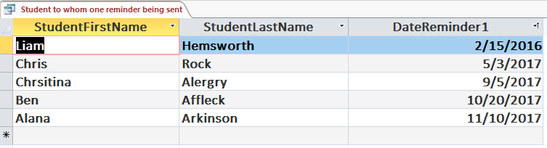

## Query 3 -

### Description

* This statement will show a list of all the rooms that are currently rented.

### SQL statement

* SELECT Room.RoomNo FROM Room INNER JOIN (Student INNER JOIN Lease ON Student.StudentNo = Lease.StudentNo) ON Room.PlaceNo = Lease.PlaceNo;

### Results

* Screenshot

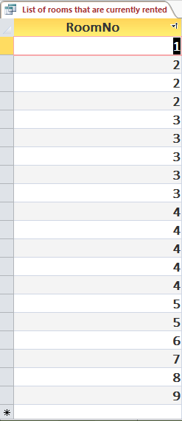

## Query 4 -

### Description

* This statement will show a list of names of students who are Male (M) and living in one of the Hall’s. For this Query design we choose Lafayete Hall.

### SQL statement

* SELECT Student.StudentFirstName, Student.StudentLastName, Hall.HallName FROM (Hall INNER JOIN Room ON Hall.HallNo = Room.HallNo) INNER JOIN (Student INNER JOIN Lease ON Student.StudentNo = Lease.StudentNo) ON Room.PlaceNo Lease.PlaceNo WHERE (Student.StudentGender)='M' AND (Hall.HallName='Lafayete Hall');

### Results

* Screenshot

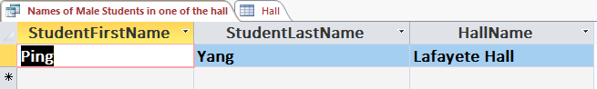

## Query 5 -

### Description

* This statement will show a list of students with their first and last name, who paid cash for the room rent.

### SQL statement

* SELECT Student.StudentFirstName, Student.StudentLastName FROM (Student INNER JOIN Lease ON Student.StudentNo = Lease.StudentNo) INNER JOIN (PaymentMethod INNER JOIN Invoice ON PaymentMethod.PaymentMethodNo = Invoice.PaymentMethodNo) ON Lease.LeaseNo = Invoice.LeaseNo WHERE (PaymentMethod.PaymentMethod)='Cash';

### Results

* Screenshot

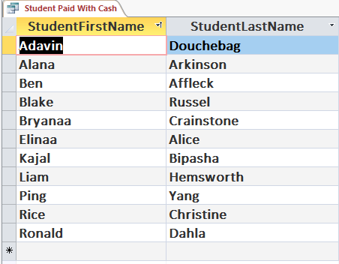

# Report

* This Report will show a list of names of students who are Male (M) and living in one of the Hall’s. For this Query design we choose Lafayete Hall.

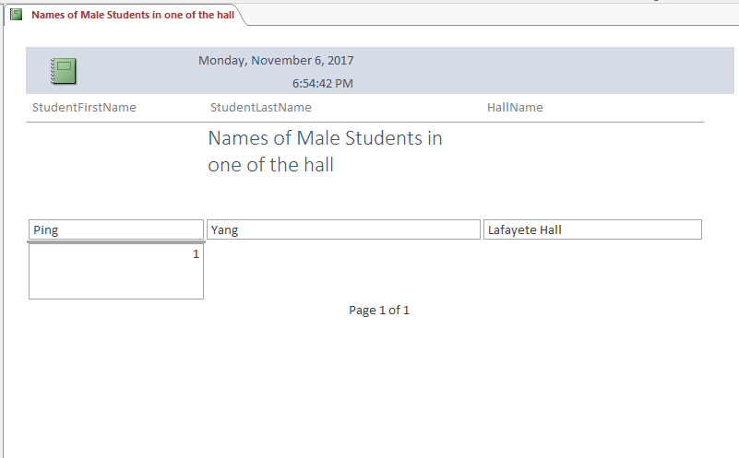

* This report will show a list of students with their first and last name, who paid cash for the room rent.

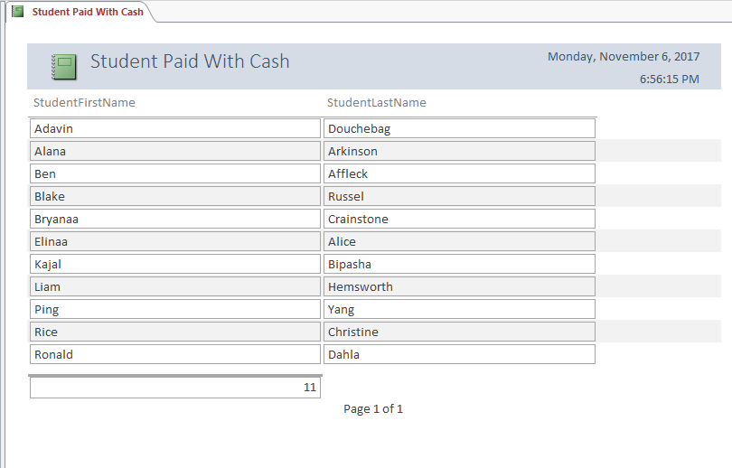

# Problems Encountered

A lot of problem has been encountered when approaching this project. These problems have been described down below, briefly.

* The first problem that I encountered was while creating data dictionary. Because the total bytes for each of the table has changed while I was doing the project. Sometimes I changed the number of records for the assignment, because of that total bytes and estimated number has changed. As such, initially I counted the record of only 15 students, but as I was proceeding on with the project, I felt like I need more than 15 students. Thus, I increased that to 25 students, which caused a change in total bytes and estimated number.
* Next when I was doing the assignment I had trouble connecting the table with each other. I have to find out which primary key is connected with which table. It took me a while to figure it and write statement of each table step by step.
* Then when I was trying to put data in each table using SQL queries, I accidentally deleted one of the INSERT Statement and accidentally entered same INSERT Statement twice, then I deleted on of them, it gave me an uneven number in the primary key. In order to fix those, I had to delete the table and rerun the query again. For that I had to re-enter the INSERT Statement again, which took me forever to do that.
* Finally, when I was trying to create my own queries I had problems understanding which Query would be best and are they going to work fine or not. Some queries I tried to use, didn’t work. As such, when I was trying to find the list of all first names of the students that start with ‘A’, it didn’t give me any information on the Query. So, I have to give on that and think of another query.

But, at the end of this assignment I can say proudly that I learned a lot. Maybe there are lot of things I need to know, or I need to learn about it, but as a whole I really loved the challenge to finish this huge assignment on time. I also loved working with my friend Daniel McCracken and got the chance to learn a lot from him.